Contact Manager Project Documentation

Team ID : 69a728d7fa5736d932f6255c
Team Leader : Akash K
Team Member: Kamaresh, Sena, Santhosh.

Introduction

- The Contact Manager is a backend web application developed using Node.js, Express.js, and MongoDB.
- The purpose of this application is to store, manage, update, and delete contact details in a database.
- The application performs CRUD operations (Create, Read, Update, Delete) on contact information such as name, email, and phone number.
- It uses REST API architecture which allows communication between the client and server through HTTP requests.

1.2. Objectives of the Project:
- To create a RESTful API using Node.js and Express.
- To store contact details in a MongoDB database.
- To perform CRUD operations on contact data.
- To test APIs using Thunder Client.
- To understand backend architecture and database integration.

1.3. Technologies Used:
- Node.js – Runtime environment for executing JavaScript on the server.
- Express.js – Web framework for building APIs.
- MongoDB – NoSQL database used to store contact information.
- Mongoose – ODM library used to interact with MongoDB.
- Thunder Client – API testing extension in Visual Studio Code.
- Nodemon – Automatically restarts the server during development.

1.4. System Architecture:
Client (Thunder Client/Postman)
↓
Express Server (API Routes)
↓
Controller Logic
↓
MongoDB Database

2. Project Folder Structure
contact-manager
│
├── config
│ └── dbConnection.js
├── controllers
│ └── contactController.js
├── models
│ └── contactModel.js
├── routes
│ └── contactRoutes.js
├── node_modules
├── .env
├── package.json
└── server.js

2.1. Database Design:
Collection Name: contacts

Fields:
• _id
• name
• email
• phone
• createdAt
• updatedAt

7. API Endpoints
Create Contact
Method: POST
URL: /api/contacts

Get All Contacts
Method: GET
URL: /api/contacts

Get Single Contact
Method: GET
URL: /api/contacts/:id

Update Contact
Method: PUT
URL: /api/contacts/:id

Delete Contact
Method: DELETE
URL: /api/contacts/:id

2.2. MongoDB Connection Example:
const mongoose = require("mongoose");

const connectDb = async () => {
try {
const connect = await mongoose.connect(process.env.CONNECTION_STRING);
console.log("Database connected");
} catch (err) {
console.log(err);
process.exit(1);
}
};
module.exports = connectDb;

2.3. Contact Model Example:
const mongoose = require("mongoose");

const contactSchema = mongoose.Schema({
name: {
type: String,
required: true
},
email: {
type: String,
required: true
},
phone: {
type: String,
required: true
}
});

module.exports = mongoose.model("Contact", contactSchema);

2.4. Testing Using Thunder Client:
1. Install Thunder Client extension in VS Code.
2. Start the server using: npm run dev
3. Open Thunder Client and create a new request.
4. Use POST, GET, PUT, and DELETE methods to test APIs.

2.5. Advantages:
• Easy contact storage and management.
• Fast database operations using MongoDB.
• Simple REST API architecture.
• Scalable backend design.

2.6. Future Enhancements:
• User authentication using JWT.
• Login and registration system.
• Contact search feature.
• Pagination for large contact lists.
• Frontend interface using React.

3. Functional Requirements:
Following are the functional requirements of the proposed solution.

FR No. | Functional Requirement (Epic) | Sub Requirement (Story / Sub-Task)
1 | User Authentication and Authorization | • User registration with name, email, and password  • User login with email and password  • JWT token generation and management  • Password encryption using bcrypt  • Session management and auto-logout on token expiration  • Protected routes requiring authentication  • User logout functionality
2 | Contact Management (CRUD Operations) | • Create new contact with name, email, phone, notes, and tags  • View all contacts for logged-in user  • View individual contact details  • Update existing contact information  • Delete contact with confirmation prompt  • Validate contact data (email format, required fields)  • Display contact count and metadata
3 | Search and Discovery | • Real-time search across contact names  • Search by email addresses  • Search by tags  • Case-insensitive search functionality  • Display search results count
4 | Data Validation and Error Handling | • Server-side validation for all API endpoints  • Email format validation  • Required field validation  • Display validation errors to user  • API error handling and user-friendly messages  • Prevent duplicate email registration
5 | Contact Information Management | • Store contact name (required)  • Store contact email (optional, validated)  • Store contact phone number (optional)  • Store contact notes/description (optional, max 1000 chars)  • Store contact tags (optional, max 10 tags)  • Timestamp for contact creation  • Timestamp for last update
6 | User Profile and Account | • Get current user information endpoint  • User-specific data isolation  • Each user accesses only their own contacts  • User ID association with all contacts
7 | Data Persistence and Storage | • Store user data in MongoDB database  • Store contacts in MongoDB database  • Maintain referential integrity (userId foreign key)  • Automatic timestamp management  • Database indexing for performance  • Secure password storage (hashed)  • LocalStorage for JWT token on client

Non-functional Requirements:
Following are the non-functional requirements of the proposed solution.

FR No. | Non-Functional Requirement | Description
1 | Security | All API requests must be secured using JWT authentication. The app should prevent unauthorized access to user data. Passwords must be hashed using bcrypt with salt rounds of 10 or higher. SQL/NoSQL injection attacks should be prevented through input validation and parameterized queries. CORS properly configured to allow only authorized origins. Sensitive data (passwords) never exposed in API responses. HTTPS enforced in production environments.
2 | Reliability | The system should handle errors gracefully without crashing. Database connections should be resilient with automatic reconnection. Failed API requests should be handled with appropriate error messages.
3 | Performance | API response times should average under 200ms. Database queries optimized with appropriate indexing. Client-side rendering should be smooth (60fps animations). Bundle size kept under 500KB for fast loading.
4 | Scalability | The app should handle increasing numbers of users and contacts efficiently without performance degradation. The architecture should support future feature expansion. Should support at least 10,000 concurrent users. Individual users should be able to store up to 10,000 contacts without performance issues. Database should scale horizontally
5 | Maintainability | The codebase should be well-organized, documented, and easy to maintain. Code should follow consistent style guidelines and best practices. Functions should be modular and single-purpose. Comments should explain complex logic. API endpoints should be clearly documented. Database schema should be well-defined. Version control with meaningful commit messages. Separate development, staging, and production environments.
6 | Compatibility | The application should work across different browsers and devices. Support for Chrome (latest 2 versions), Firefox (latest 2 versions), Safari (latest 2 versions), Edge (latest 2 versions). Mobile support for iOS 12+ and Android 8+. Responsive design working on screen sizes from 320px to 2560px. No dependency on specific operating systems. API compatible with different client types (web, mobile, future integrations).

4. Screenshorts:

MONGODB SERVER CONNECTION:

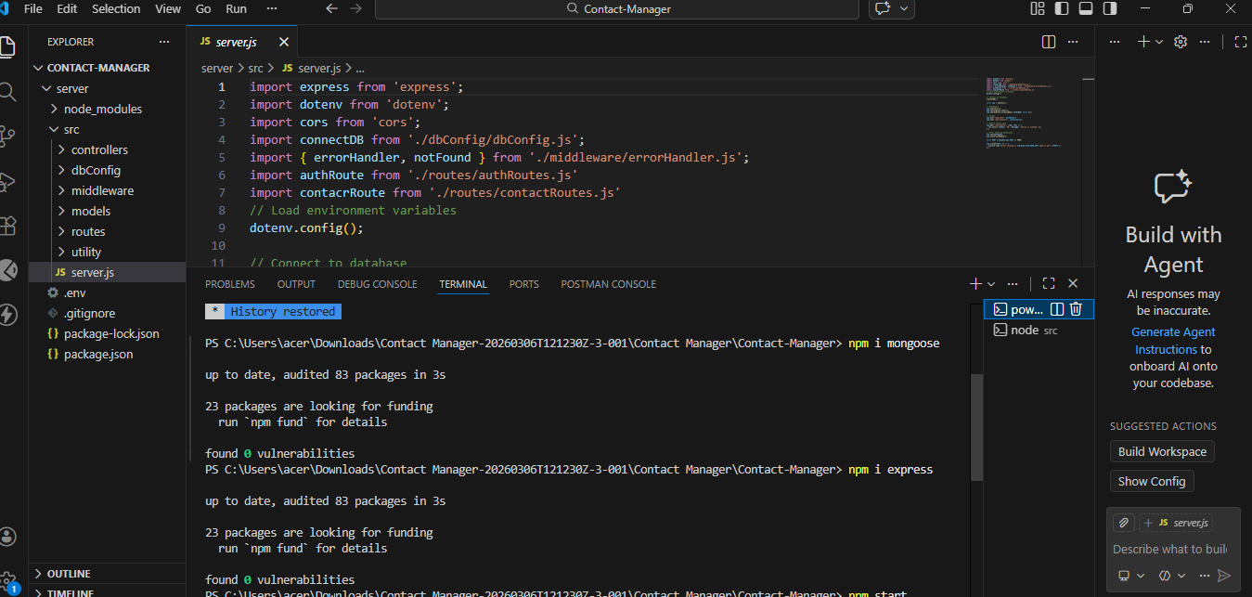
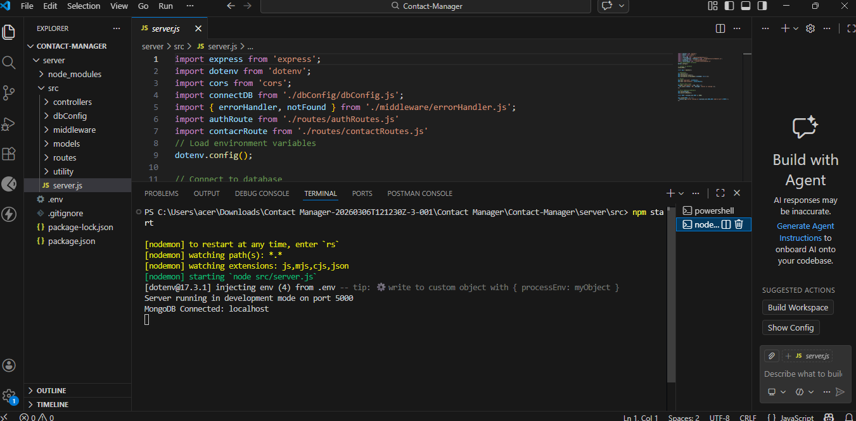

CREATING A CONTACT REGISTER IN THUNDER:

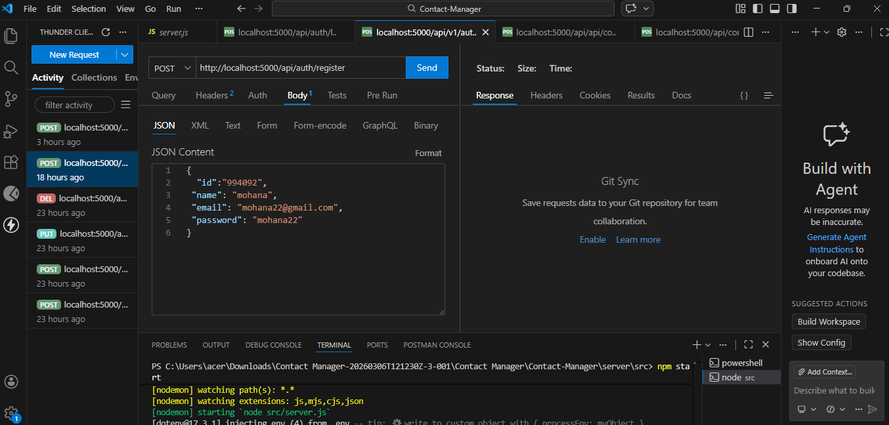
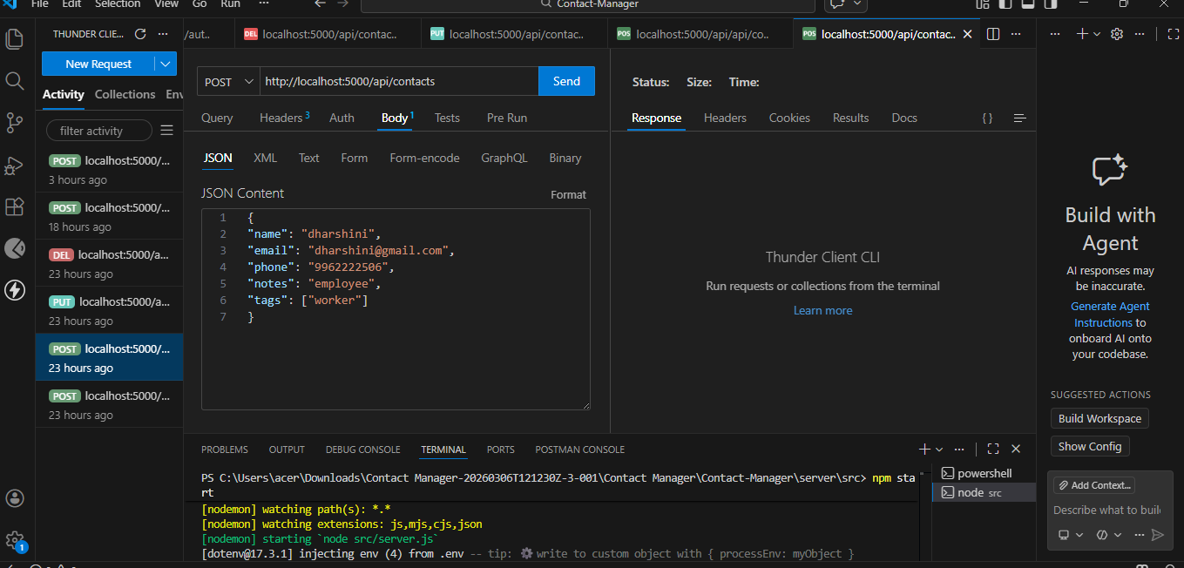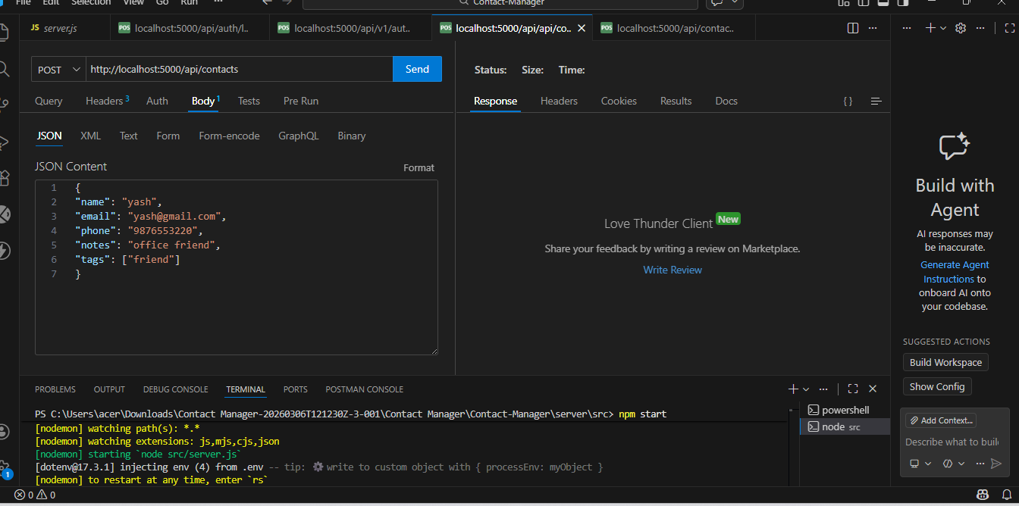

UPDATING CONTACT:

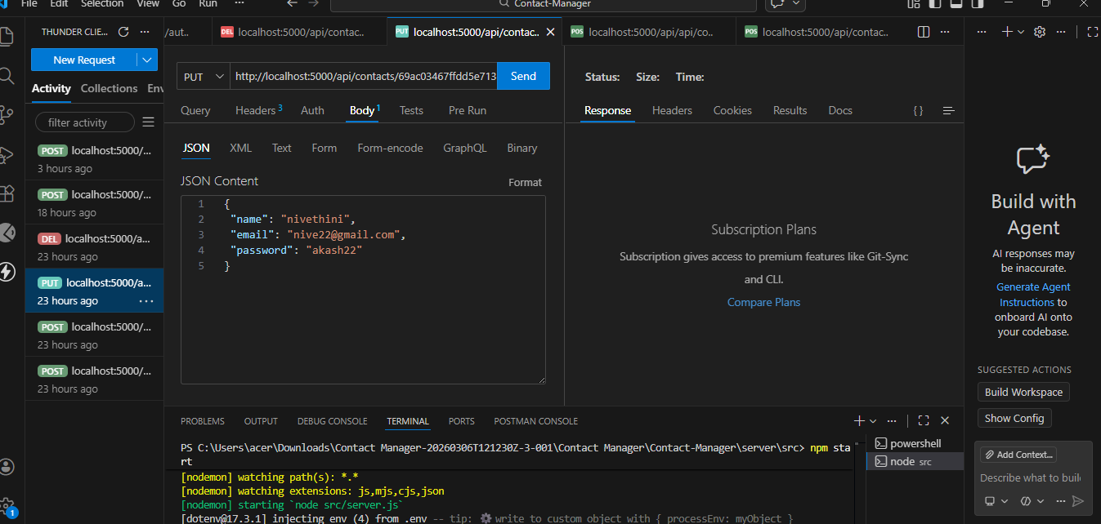
DELETING CONTACT:
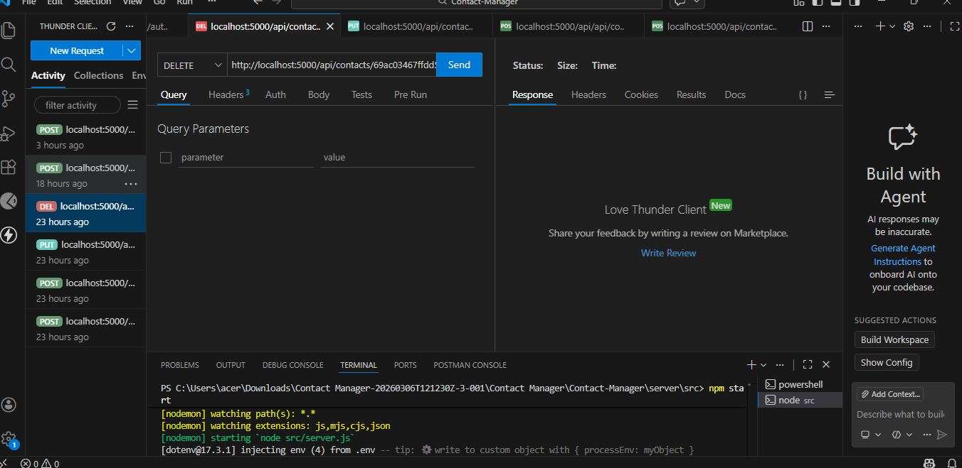

15. Conclusion
The Contact Manager project demonstrates how to build a REST API using Node.js and MongoDB.
It helps developers understand backend concepts like routing, controllers, database operations,
and API testing. This project serves as a strong foundation for developing full-stack applications.

